CSCI336 Assessment 3 Test Cases

Name : Lau Yan Chen Daryl
Student No. : 4033747

General Instructions

1) Prepare the following :

(i) Setup the exact same version of your program (submitted 1 day earlier
via email) to perform the test cases

- Open up Excel document ‘CSCI336_A3_Criteria_Checklist.xls‘

2) Perform test cases SEQUENTIALLY on your program, do not skip steps / sequence!

3) FOR EACH test case :

  - Perform the test case on your program

  - If your program ‘pass’ the test case

- Do screen capture, and paste the image in this document
(CSCI336_A3_Test_Cases.doc), where indicated

- Update CSCI336_A3_Criteria_Checklist.xls (select ‘yes’) at the row corresponding to your test case

Else // i.e. program ‘fails’ the test case

- No need for screen capture (leave the section blank)

- Update CSCI336_A3_Criteria_Checklist.xls (select ‘no’) at the
row corresponding to your test case

4) Note : Please RESIZE your screen capture, Adjust the Spacing such that each test case begins on a new page !!

Test Case #1 – Implementing Room (Environment)

- Start your program

- Do a screen capture that provides an “overall” view of your room with all its objects

- Using MS Word’s arrows and textboxes, CLEARLY label the following objects:

  - The 4 walls
  - At least 1 table
  - At least 2 chairs

NOTE :
If you are doing Advanced Task, please provide labeling for BOTH Orthographic &
Perspective sub-windows, for each object !!

<Test Case #1 : Paste Screen Capture(s) + labeling below >

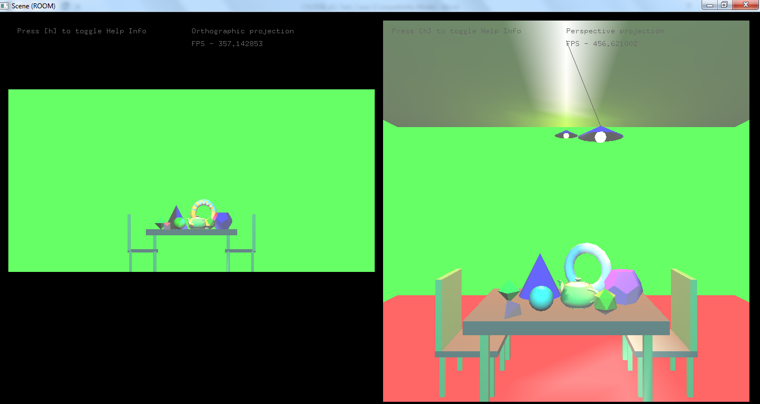

Walls
Tables
Walls
Chairs
Tables
Chairs

Test Case #2 – Implementing Table Ornaments (with material properties values)

- Start your program

- Do a screen capture that provides an “overall” view of your room with all its objects

- Using MS Word’s arrows and textboxes, CLEARLY label the following objects:

  - glutSolidTeapot
  - glutSolidSphere
  - glutSolidCone
  - glutSolidTorus
  - glutSolidDodecahedron
  - glutSolidOctahedron
  - glutSolidTetrahedron
  - glutSolidIcosahedron

NOTE (1) :
In CSCI336_A3_Criteria_Checklist.xls, please fill up the material properties values (Ambient, Diffuse, etc) for each object (in the corresponding row) from column E onwards.

NOTE (2) :
If you are doing Advanced Task, please provide labeling for BOTH Orthographic &
Perspective sub-windows, for each object !!

<Test Case #2 : Paste Screen Capture(s) + labeling below >

Teapot
Sphere
Cone
Torus

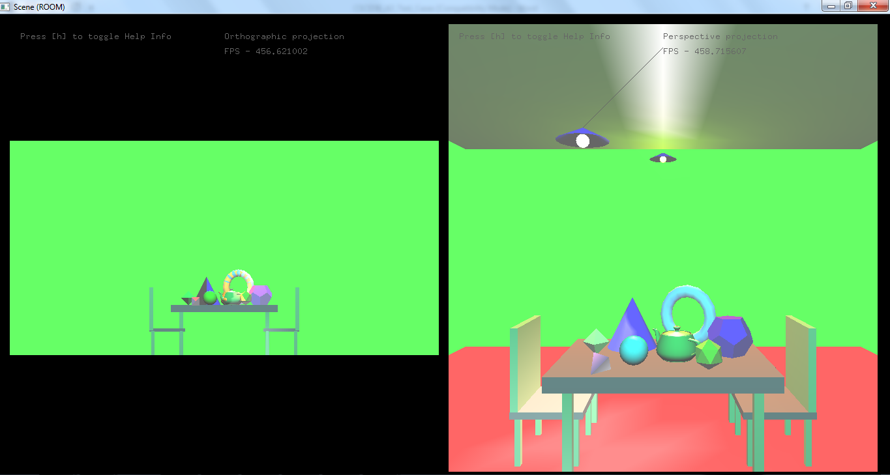

dodecahedron
tetrahedron
isosahedron
octahedron

Test Case #3a & #3b – Implementing Light Sources 1 & 2

- Start your program

- Do a screen capture that provides an “overall” view of your room with all its objects

- With the exception of the 2 Light Sources (at opposite sides of the room), switch OFF all other light sources

- Using MS Word’s arrows and textboxes, CLEARLY label the “Light Source 1” and “Light Source 2”, showing them located at OPPOSITE SIDES of the room

NOTE (1) :
In CSCI336_A3_Criteria_Checklist.xls, please fill up the lighting properties values (Ambient, Diffuse, etc) for each light source (in the corresponding row) from column E onwards.

NOTE (2) :
If you are doing Advanced Task, please provide labeling for BOTH Orthographic &
Perspective sub-windows, for each light source !!

<Test Case #3a & #3b : Paste Screen Capture(s) + labeling below >

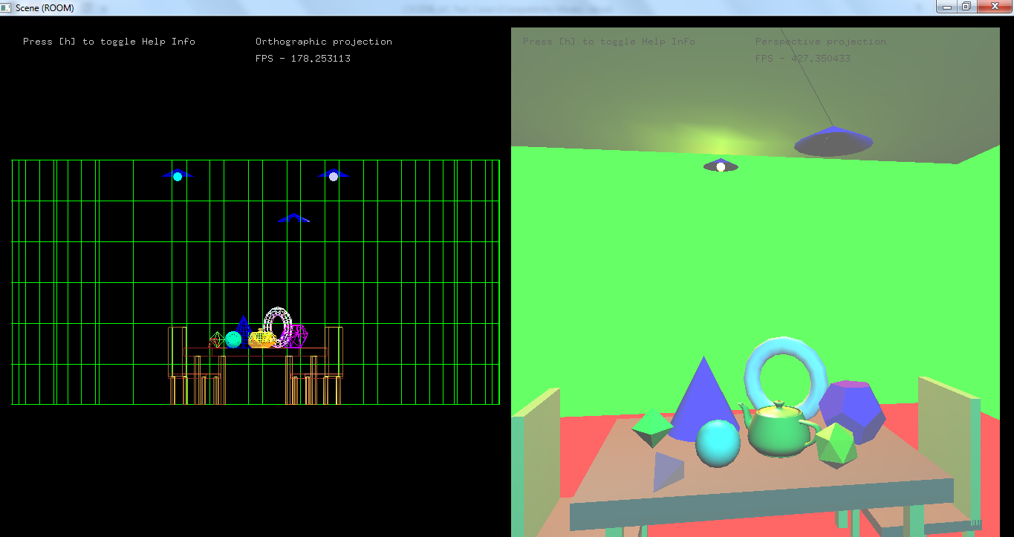

Light Source 1

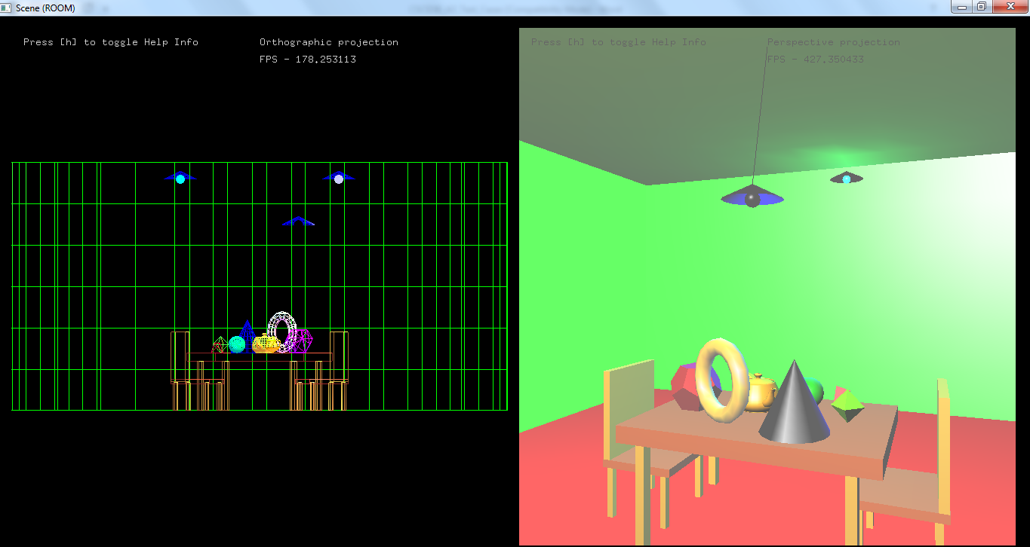

Light Source 2

Test Case #3c – Implementing Global Ambient Lighting Levels

- Start your program

- With the exception of the Light Source 1, switch OFF all other light sources

- Do 3 screen captures. Use the following lighting levels before doing the screen capture:

- Screen Capture 1 – with Global Ambient Lighting Level set to “Weakest” / “Dim-mest”

- Screen Capture 2 – with Global Ambient Lighting Level set to “Medium” / “Normal”

- Screen Capture 3 – with Global Ambient Lighting Level set to “Brightest”

NOTE :
In CSCI336_A3_Criteria_Checklist.xls, please fill up the lighting properties values (Ambient, Diffuse, etc) for Global Ambient Lighting Levels (in the corresponding row) from column E onwards.

<Test Case #3c : Paste Screen Capture 1
=> Global Ambient Level set to “Weakest” / “Dim-mest” >

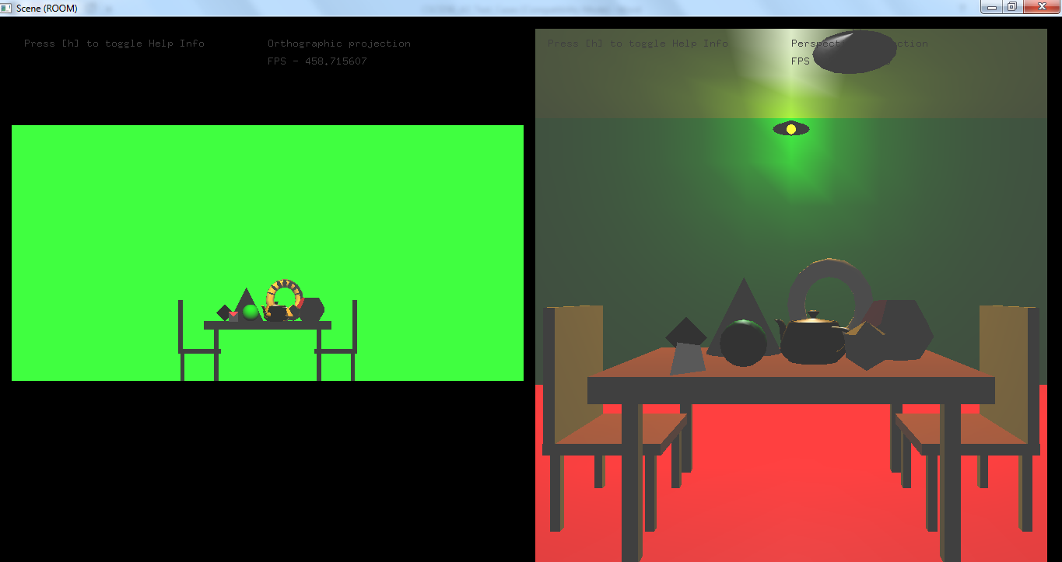

<Test Case #3c : Paste Screen Capture 2
=> Global Ambient Level set to “Medium” / “Normal” >

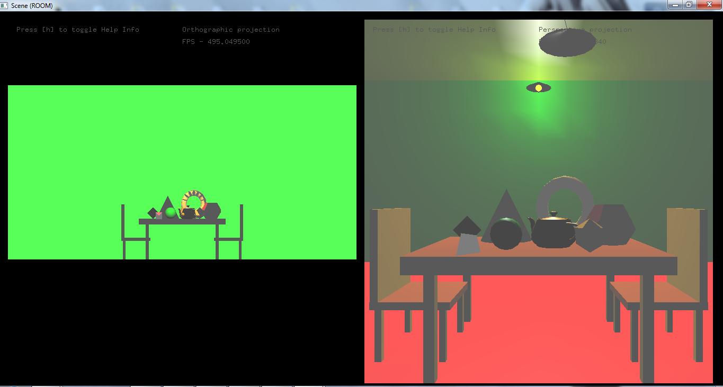

<Test Case #3c : Paste Screen Capture 3
=> Global Ambient Level set to “Brightest” >

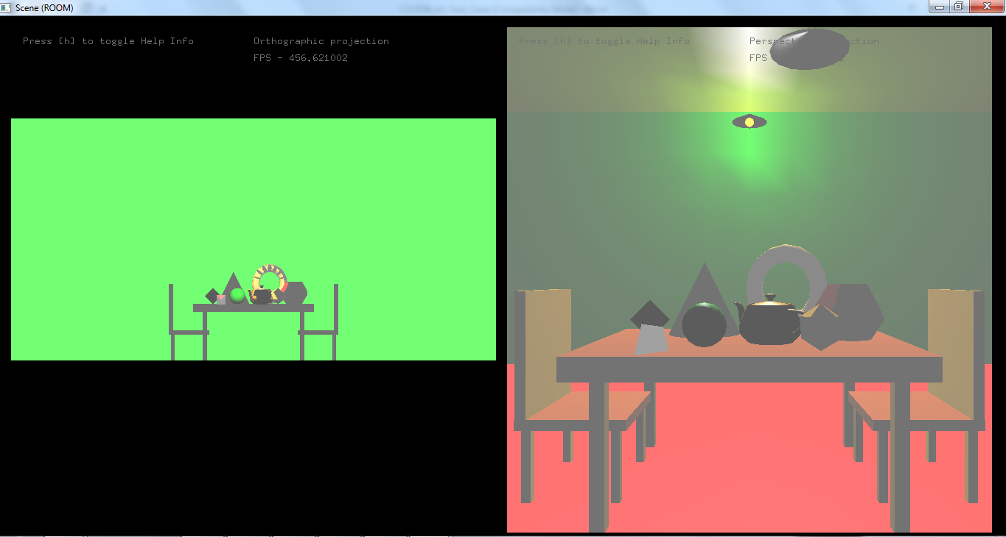

Test Case #3d – Implementing Swinging Spot Light

- Start your program

- With the exception of the Swinging Spot Light, switch OFF all other light sources

- Do 3 screen captures. Use the following positions before doing a screen capture:

  - Screen Capture 1 – with spot light swung to LEFT of the room

  - Screen Capture 2 – with spot light swung to CENTER of the room

  - Screen Capture 2 – with spot light swung to RIGHT of the room

NOTE :
In CSCI336_A3_Criteria_Checklist.xls, please fill up the lighting properties values (Ambient, Diffuse, etc) for Swinging Spot Light (in the corresponding row) from column E onwards.

<Test Case #3d : Paste Screen Capture 1
=> Swinging Spot Light swung to LEFT of the room >

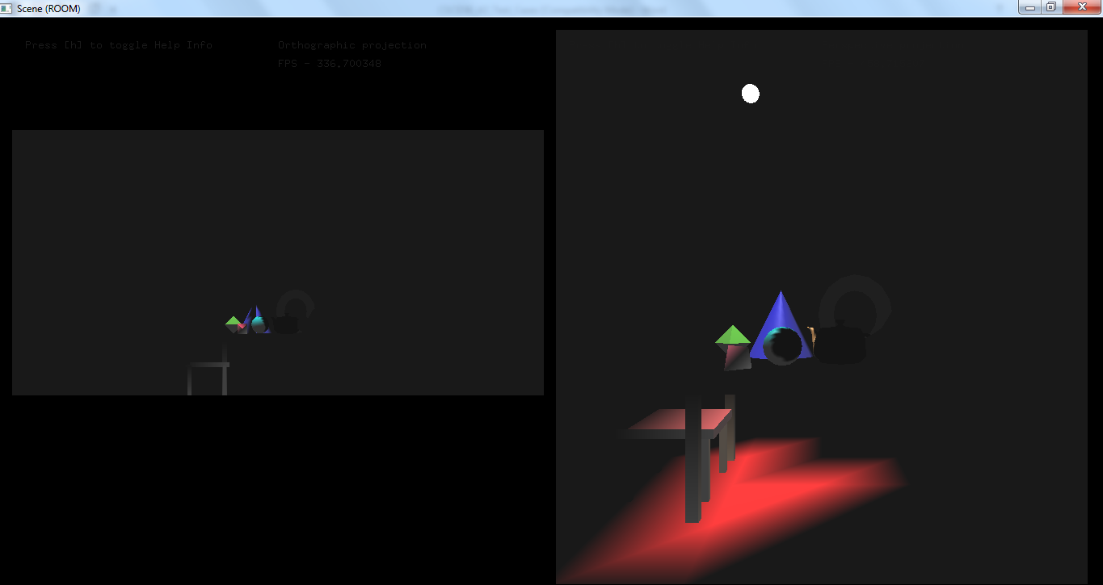

<Test Case #3d : Paste Screen Capture 2
=> Swinging Spot Light swung to CENTER of the room >

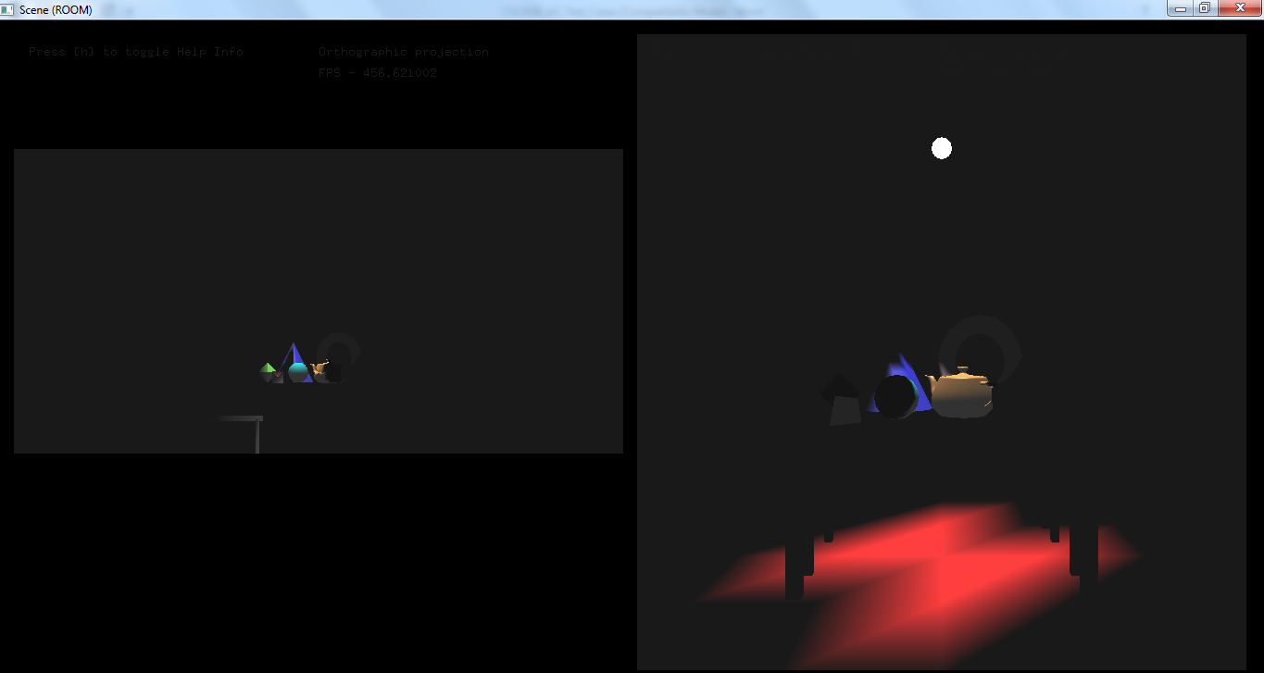

<Test Case #3d : Paste Screen Capture 3
=> Swinging Spot Light swung to RIGHT of the room >
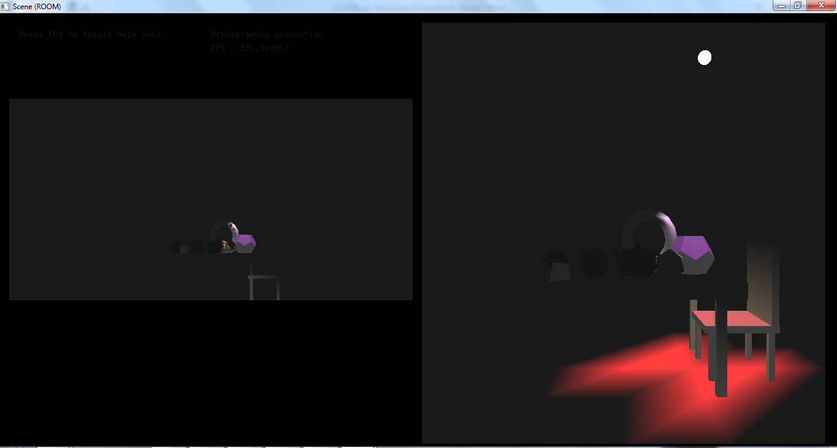

Test Case #3e – Adjust SPEED of Swinging Spot Light

- Raise your hand & call out to your tutor when you finished Test Cases 1 – 3d and updated the entries in CSCI336_A3_Criteria_Checklist.xls

- Demo your program to your tutor, to prove that you can adjust the SPEED of the swinging spotlight

- If your demo is successful, remind your tutor to note this in his namelist!

<Test Case #3e : No need to paste screen capture! Remember to update your Excel checklist … >

Test Case #4a – Keyboard key(s) to toggle Light Source 1

- Start your program

- With the exception of the 2 Light Sources (at opposite sides of the room), switch OFF all other light sources

- Leaving Light Source 2 on, do the following screen captures:

- Screen Capture 1 – with Light Source 1 off

- Screen Capture 2 – with Light Source 1 on

- In CSCI336_A3_Criteria_Checklist.xls, for test case #4a, in column E, type in the keyboard key(s) to press, to toggle Light Source 1’s on / off

<Test Case #4a : Paste Screen Capture 1
=> Light Source 1 “Off” >

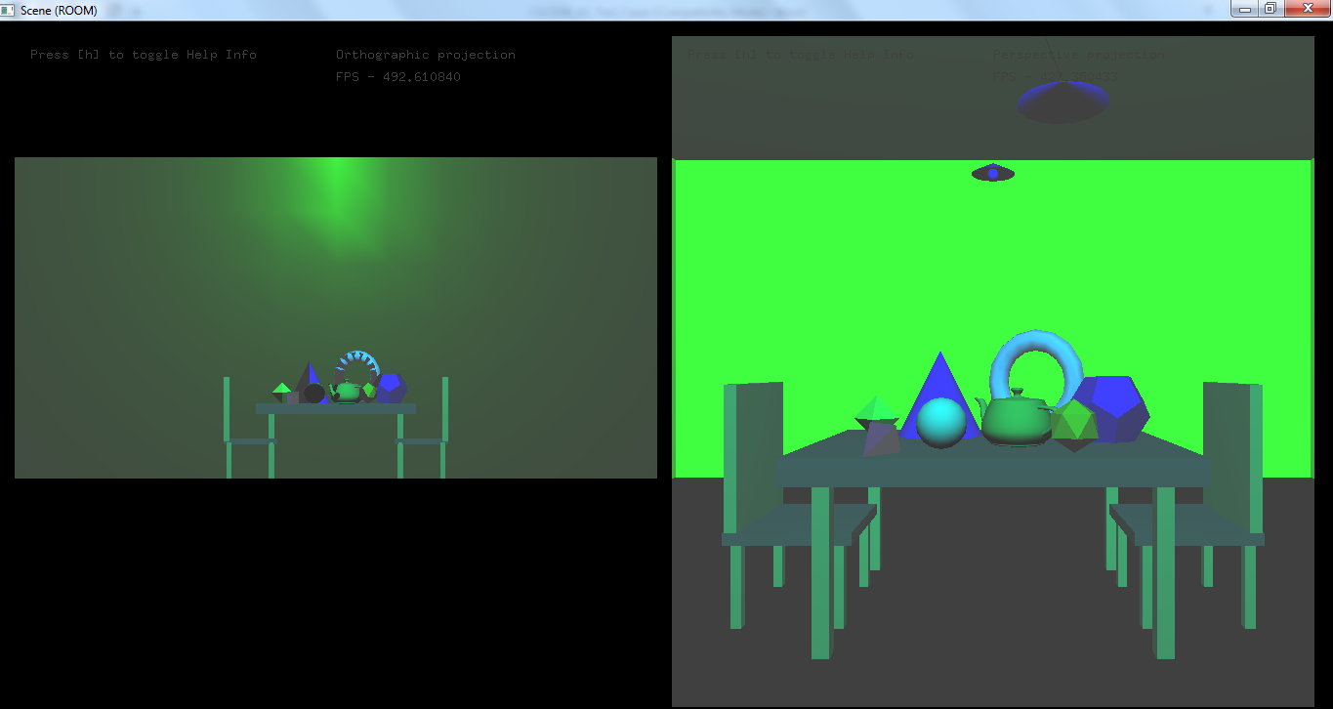

<Test Case #4a : Paste Screen Capture 2
=> Light Source 1 “On” >

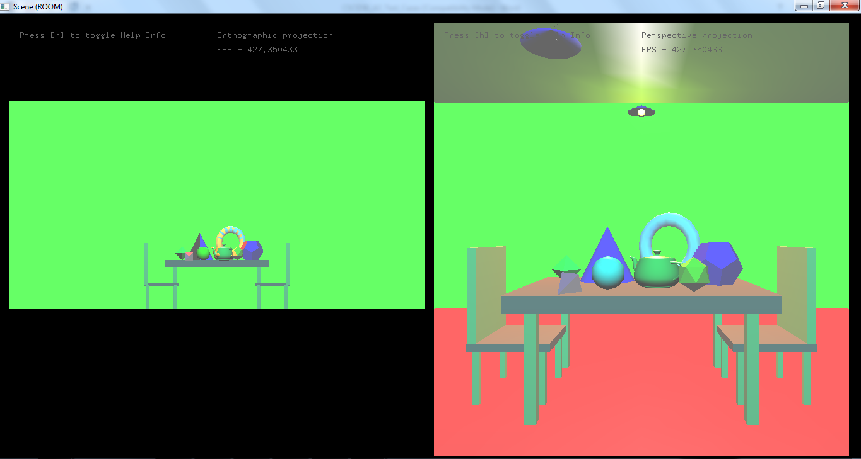

Test Case #4b – Keyboard key(s) to toggle Light Source 2

- Start your program

- With the exception of the 2 Light Sources (at opposite sides of the room), switch OFF all other light sources

- Leaving Light Source 1 on, do the following screen captures:

- Screen Capture 1 – with Light Source 2 off

- Screen Capture 2 – with Light Source 2 on

- In CSCI336_A3_Criteria_Checklist.xls, for test case #4b, in column E, type in the keyboard key(s) to press, to toggle Light Source 2’s on / off

<Test Case #4b : Paste Screen Capture 1
=> Light Source 2 “Off” >

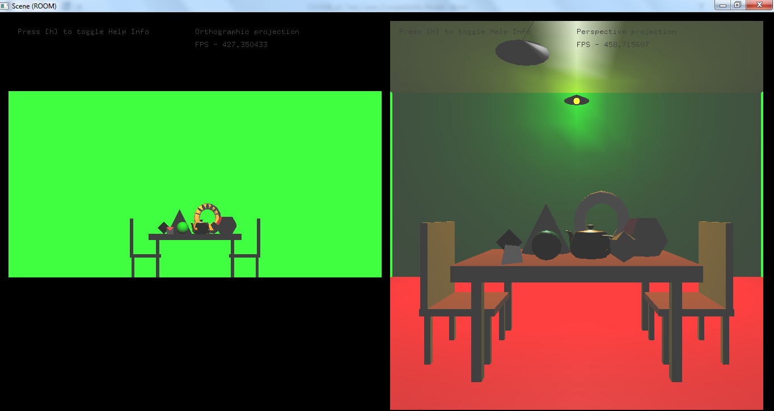

<Test Case #4b : Paste Screen Capture 2
=> Light Source 2 “On” >

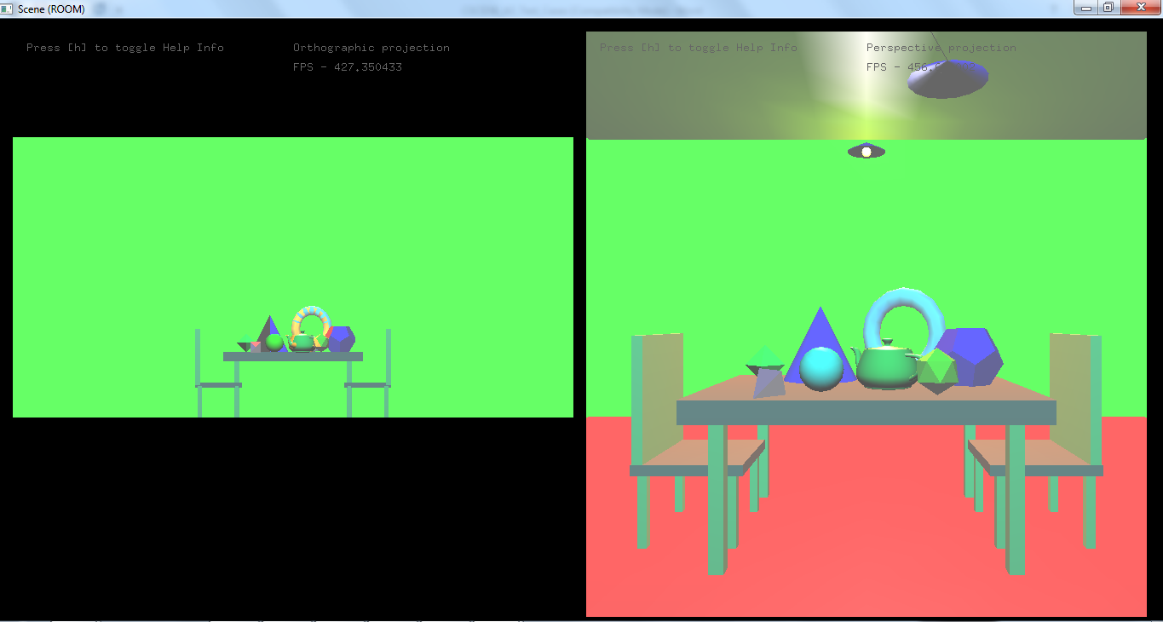

Test Case #4c – Keyboard key(s) to toggle Swinging Spotlight

- Start your program

- With the exception of Light Source 1 and Swinging Spotlight, switch OFF all other light sources

- Leaving Light Source 1 on, do the following screen captures:

- Screen Capture 1 – with Swinging Spotlight off

- Screen Capture 2 – with Swinging Spotlight on

- In CSCI336_A3_Criteria_Checklist.xls, for test case #4c, in column E, type in the keyboard key(s) to press, to toggle Swinging Spotlight’s on / off

<Test Case #4c : Paste Screen Capture 1
=> Swinging Spotlight “Off” >

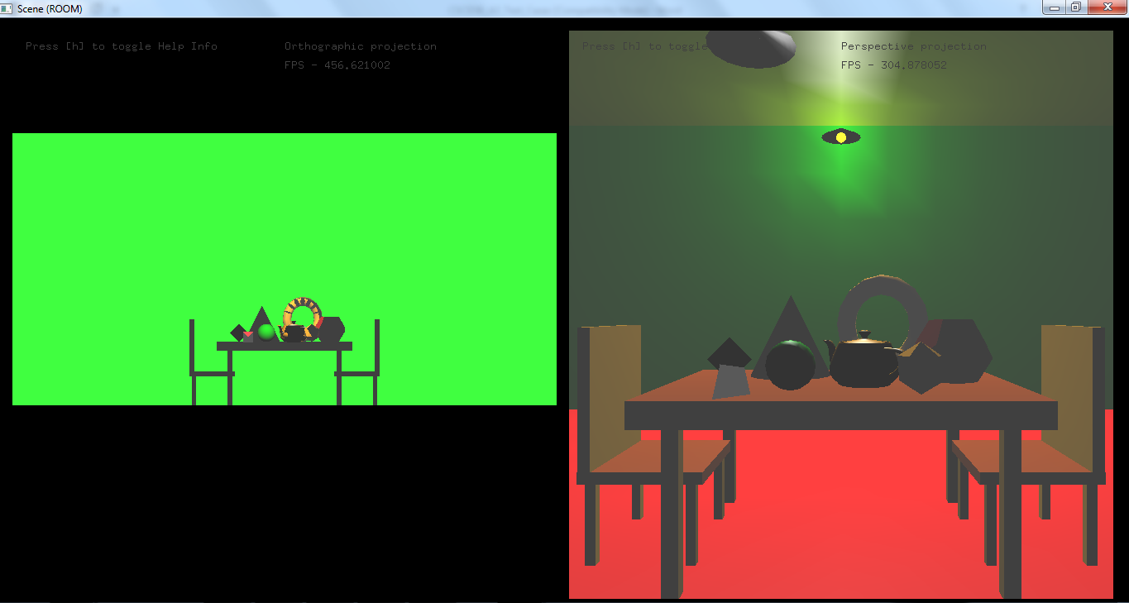

<Test Case #4c : Paste Screen Capture 2
=> Swinging Spotlight “On” >

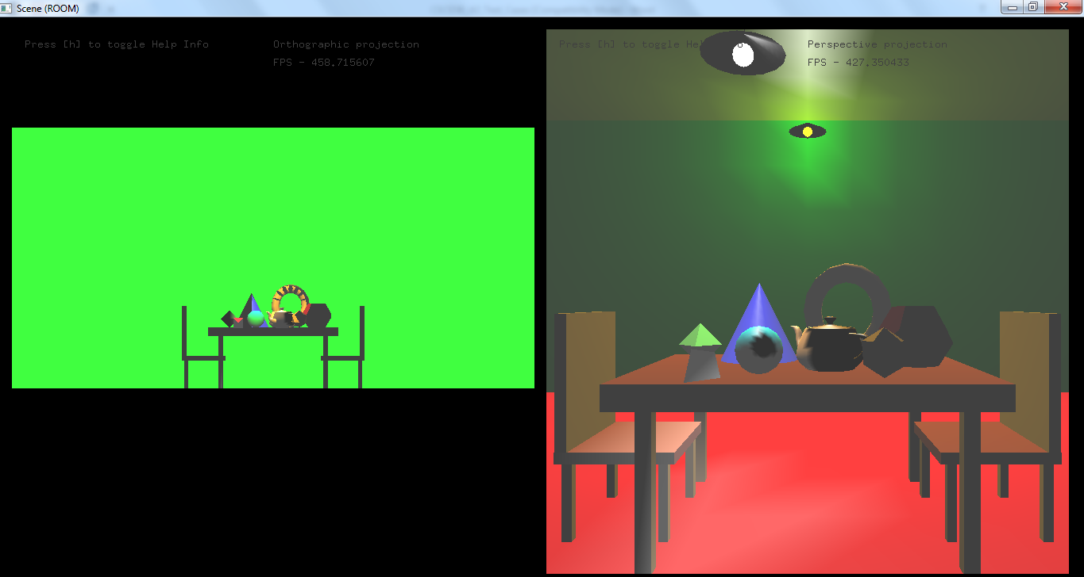

Test Case #4d – Keyboard key(s) to toggle Wireframe vs Solid mode

- Start your program

- With the exception of the 2 Light Sources (at opposite sides of the room), switch OFF all other light sources

- Do the following screen captures:

- Screen Capture 1 – room in Wireframe mode

- Screen Capture 2 – room in Solid mode

- In CSCI336_A3_Criteria_Checklist.xls, for test case #4d, in column E, type in the keyboard key(s) to press, to toggle Wireframe / Solid mode

<Test Case #4d : Paste Screen Capture 1
=> Room in Wireframe mode >

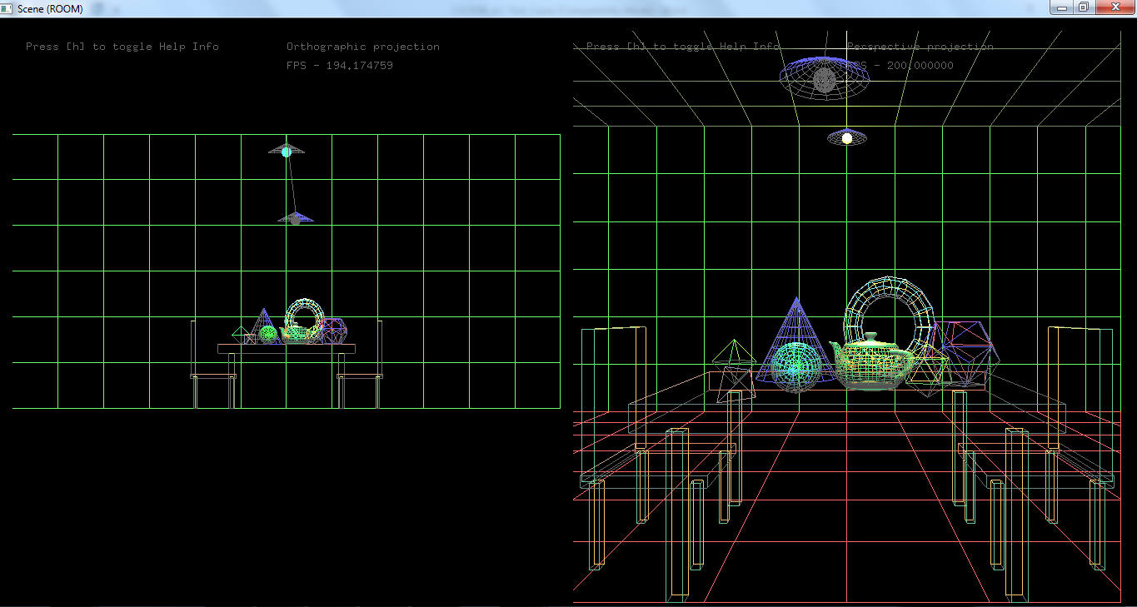

<Test Case #4d : Paste Screen Capture 2
=> Room in Solid mode >
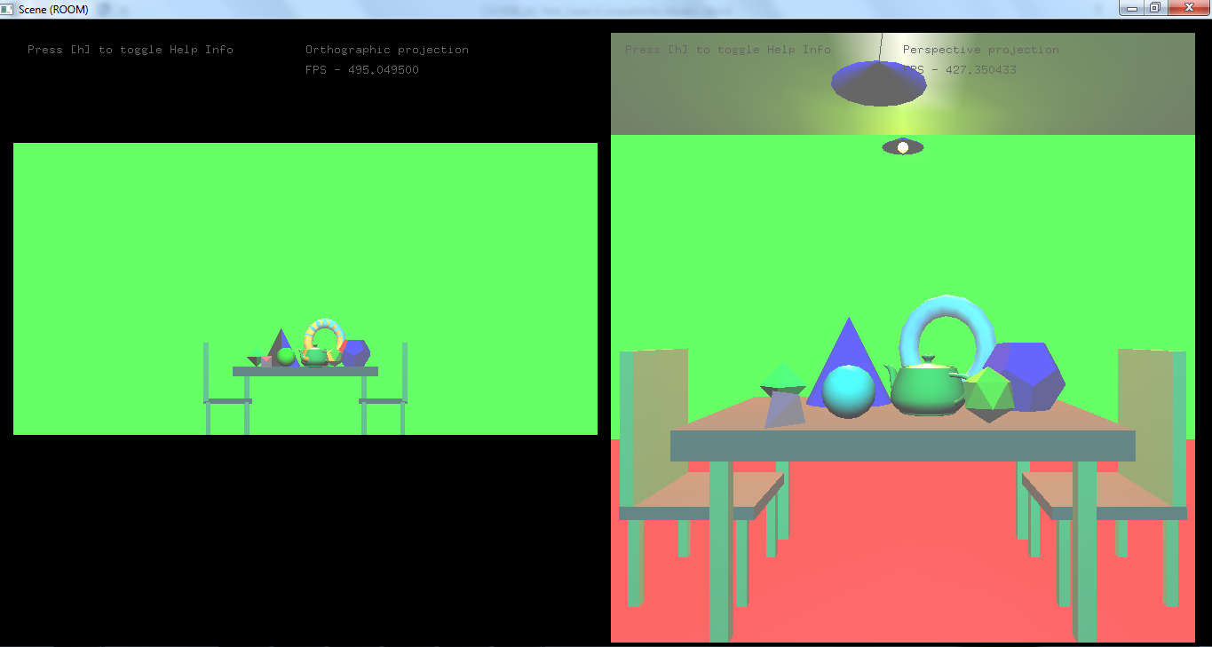

Test Case #4e – Keyboard key(s) to toggle Smooth vs Flat shading

- Start your program

- Do the following screen captures:

- Screen Capture 1 – room with Smooth shading

- Screen Capture 2 – room in Flat shading

- In CSCI336_A3_Criteria_Checklist.xls, for test case #4e, in column E, type in the keyboard key(s) to press, to toggle Smooth / Flat shading

<Test Case #4e : Paste Screen Capture 1
=> Room with Smooth Shading >

<Test Case #4e : Paste Screen Capture 2
=> Room with Flat Shading >

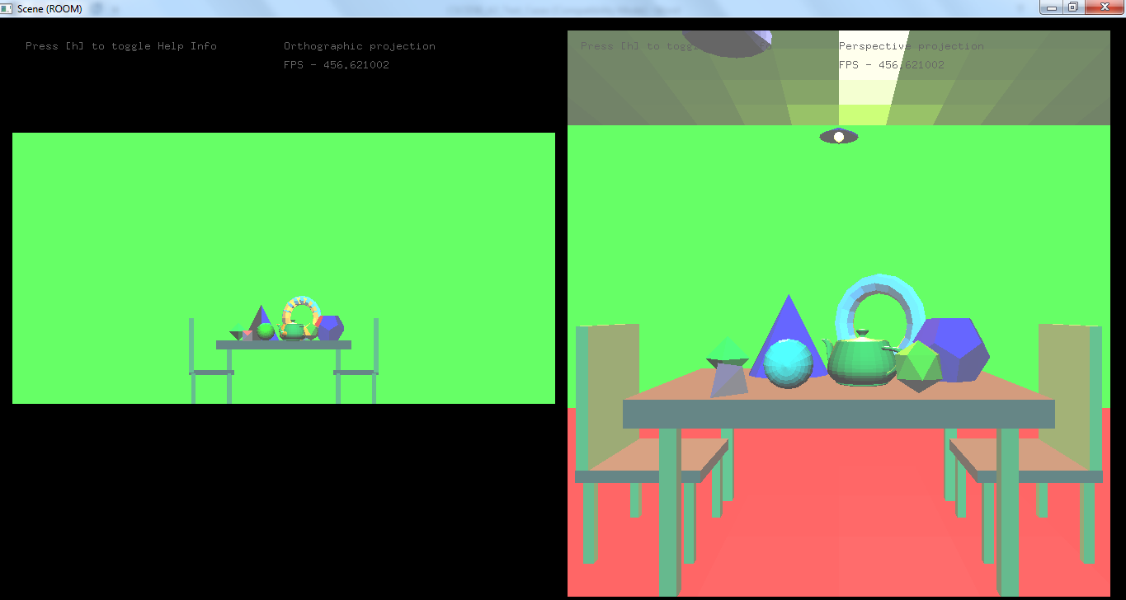

Test Case #4f – Keyboard key(s) to enable / disable Color Tracking

- Start your program

- Do the following screen captures:

- Screen Capture 1 – room with Color Tracking ENABLED

- Screen Capture 2 – room with Color Tracking DISABLED

- In CSCI336_A3_Criteria_Checklist.xls, for test case #4f, in column E, type in the keyboard key(s) to press, to enable / disable Color Tracking

<Test Case #4f : Paste Screen Capture 1
=> Room with Color Tracking ENABLED >

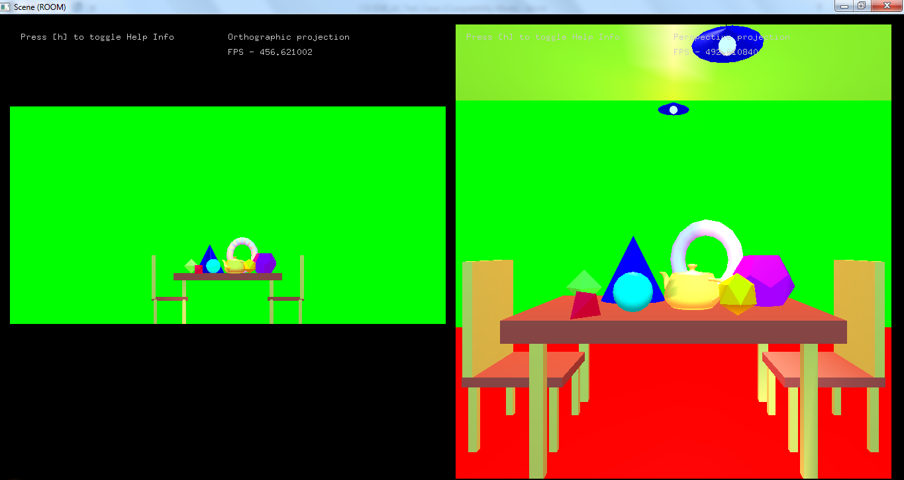

<Test Case #4f : Paste Screen Capture 2
=> Room with Color Tracking DISABLED >

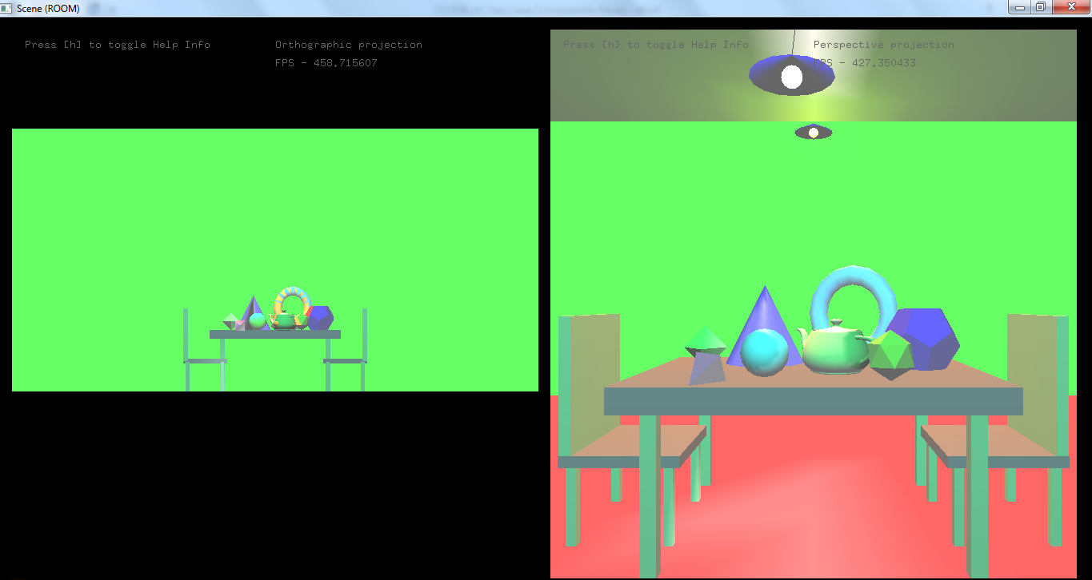

Test Case #4g, #4h & #4i – Keyboard key(s) to toggle Help Display

- Start your program

- Do the following screen captures:

- Screen Capture 1 – with Help Display off

- Screen Capture 2 – with Help Display on

- For Screen Capture 2, using MS Word’s arrows and textboxes, CLEARLY label the no. of frames displayed, on the upper-left section of the screen

- In CSCI336_A3_Criteria_Checklist.xls, for test case #4g, in column E, type in the keyboard key(s) to press, to toggle Help Display

<Test Case #4g : Paste Screen Capture 1
=> Help Display “Off” >

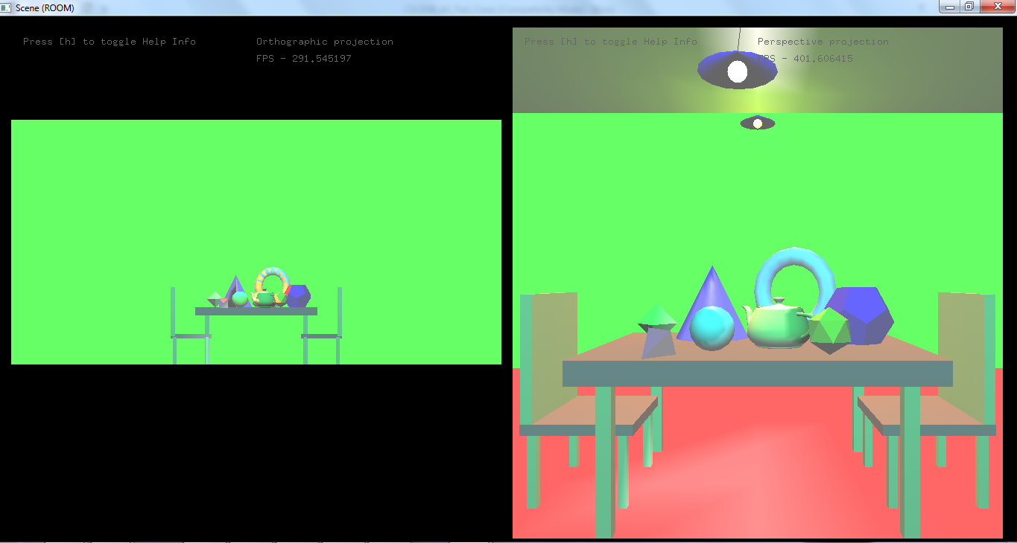

<Test Case #4g : Paste Screen Capture 2
=> Help Display “On” with labeling >

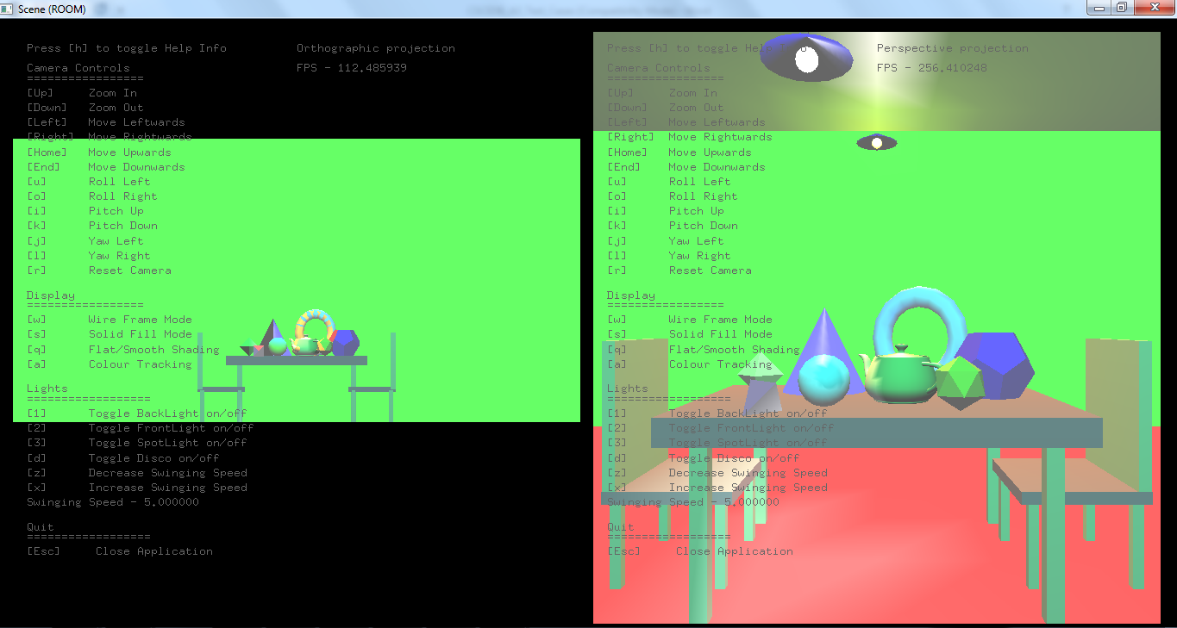

Test Case #5a & #5b – Camera rotation around fixed point P

- Start your program

- With camera focusing on point P at the CENTER of the room, at all times, do the following screen captures:

- Screen Capture 1 – view of the room with camera positioned at 1st corner of the room

- Screen Capture 2 – view of the room with camera positioned at 2nd corner of the room

- Screen Capture 3 – view of the room with camera positioned at 3rd corner of the room

- Screen Capture 4 – view of the room with camera positioned at 4th corner of the room

<Test Case #5b : Paste Screen Capture 1
=> View of the room, with camera placed at 1st corner of the room >

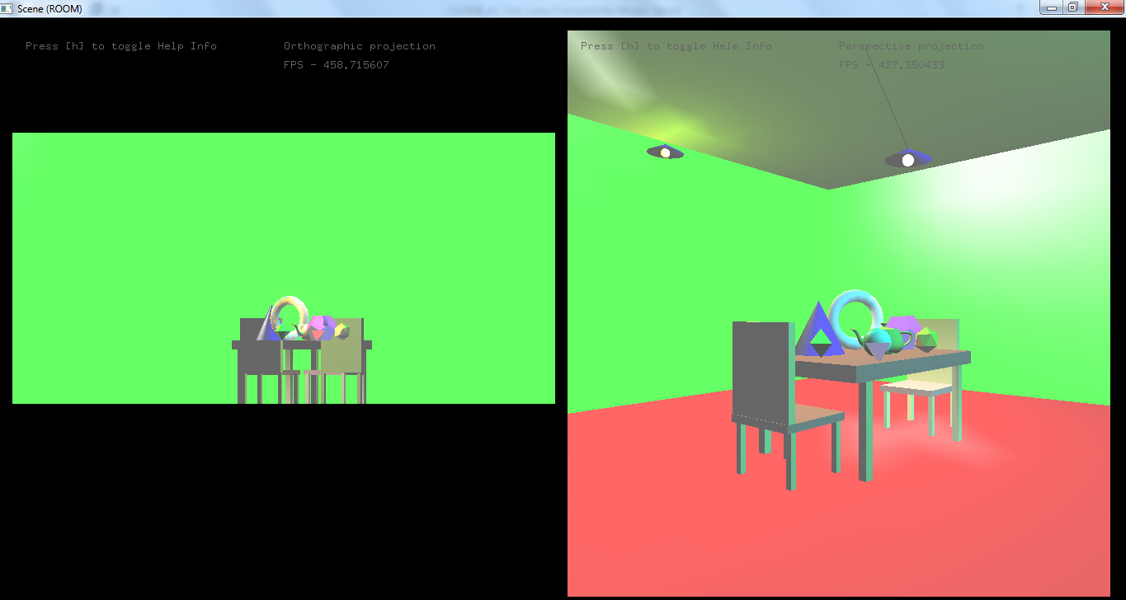

<Test Case #5b : Paste Screen Capture 2
=> View of the room, with camera placed at 2nd corner of the room >

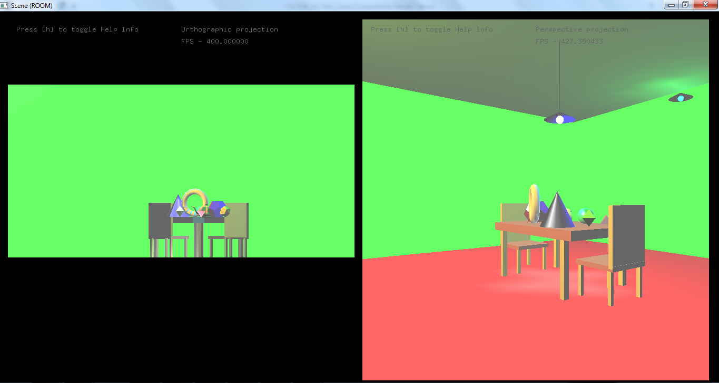

<Test Case #5b : Paste Screen Capture 3
=> View of the room, with camera placed at 3rd corner of the room >

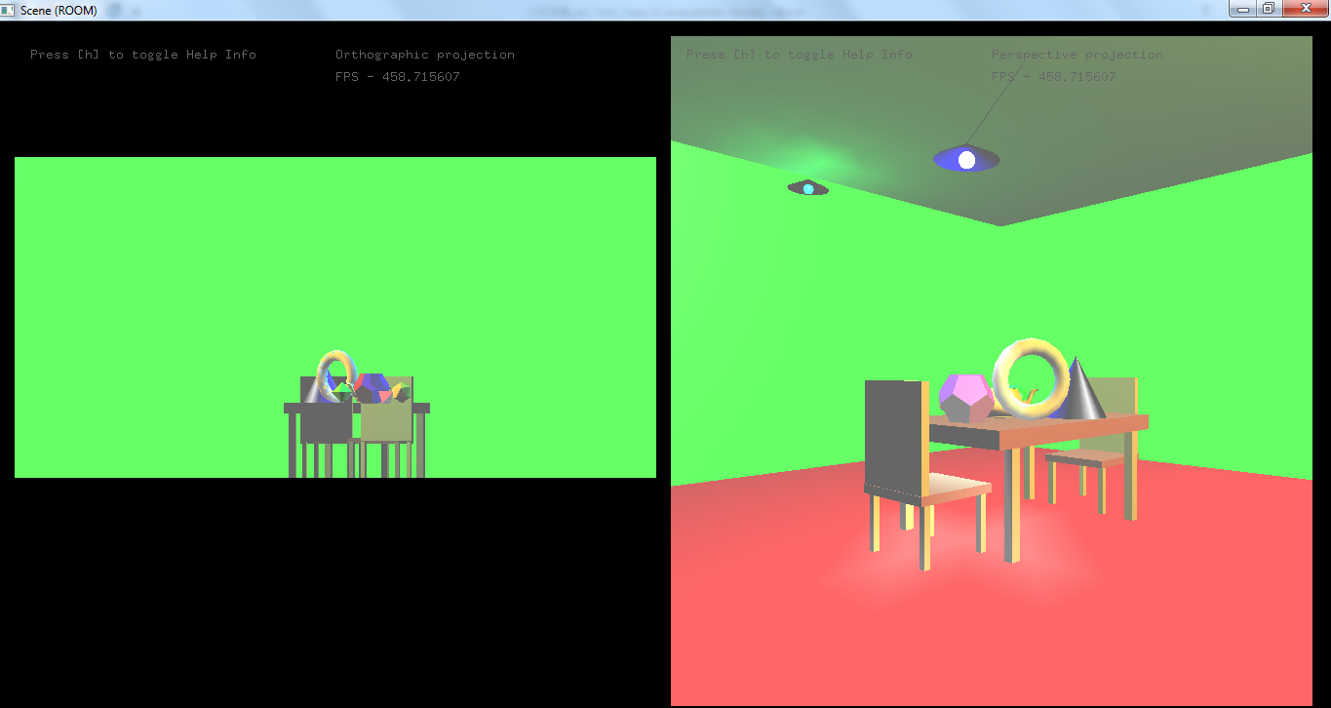

<Test Case #5b : Paste Screen Capture 4
=> View of the room, with camera placed at 4th corner of the room >

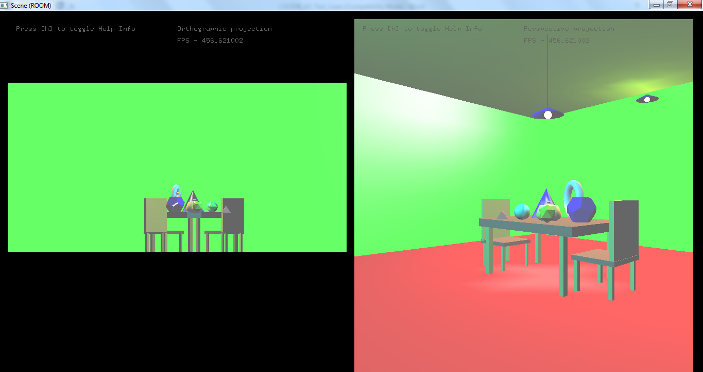

Test Case #5c– Zoom In / Out function

- Start your program

- Do the following screen captures:

- Screen Capture 1 –
Provide a Zoom-Out view, such that the entire room occupies only 1/3 (one-third) of your program’s window screen

- Screen Capture 2 –
Provide a Zoom-In view, such that the table surface occupies the whole of your program’s window screen

<Test Case #5c : Paste Screen Capture 1
=> Zoom Out, where entire room occupies only 1/3 of your program’s window screen >

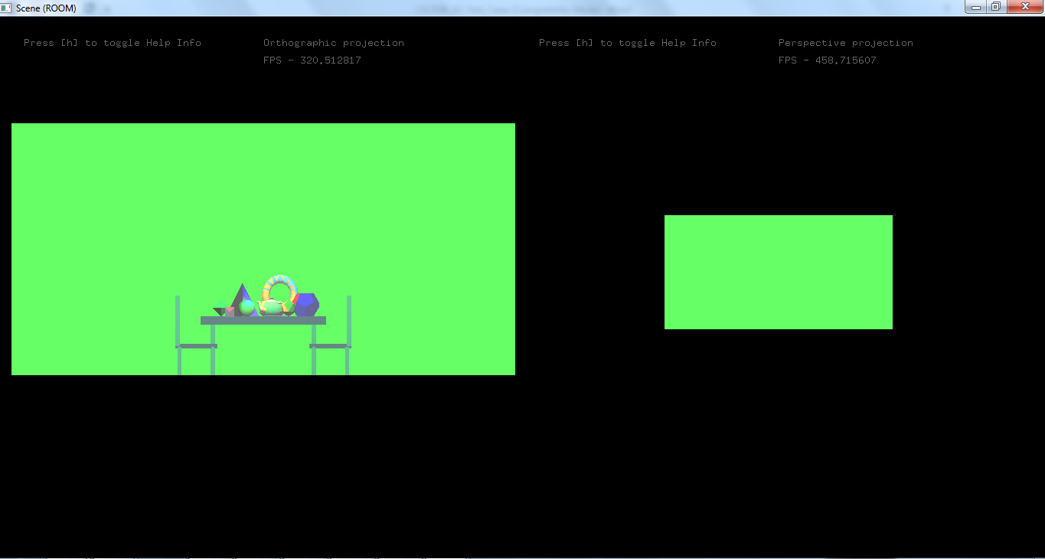

<Test Case #5c : Paste Screen Capture 2
=> Zoom In, where the table surface occupies the whole of your program’s window screen >

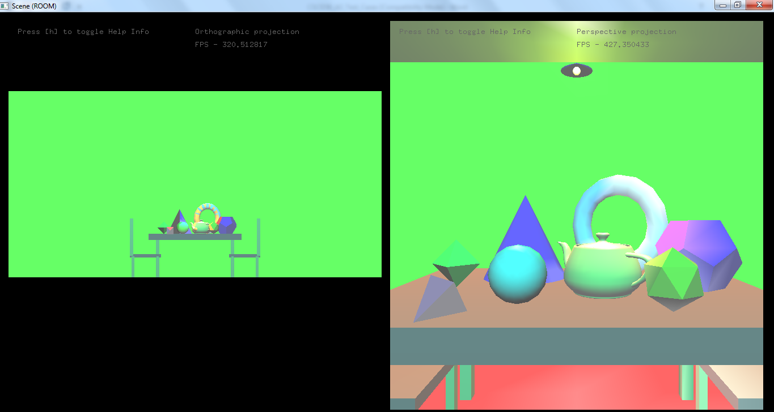

Test Case #5d – Camera Roll function (+/- 45 degrees)

- Start your program

- Do the following screen captures:

- Screen Capture 1 – Roll your camera by +45 degrees and do a screen capture

- Screen Capture 2 – Roll your camera by -45 degrees and do a screen capture

<Test Case #5d : Paste Screen Capture 1
=> View of the room, with camera rolled by +45 degrees>

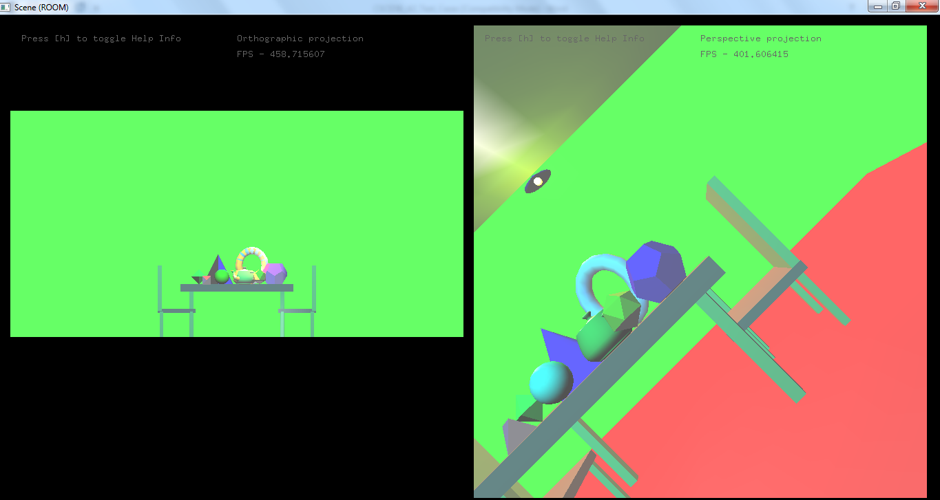

<Test Case #5d : Paste Screen Capture 2
=> View of the room, with camera rolled by - 45 degrees>

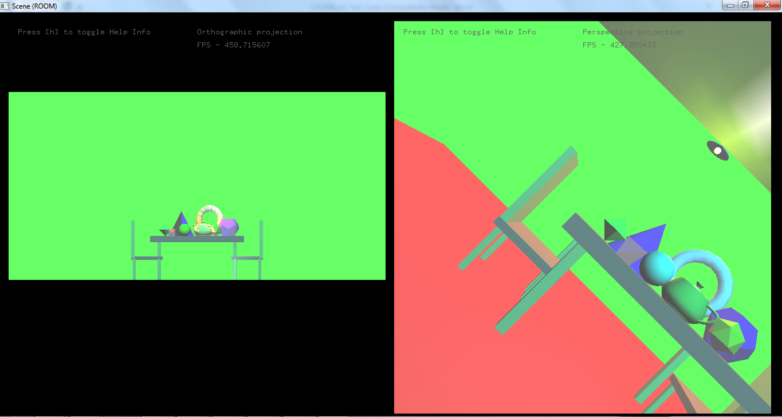

Test Case #5e – Reset Camera to default position

- Raise your hand & call out to your tutor when you finished Test Cases 1 – 5d and updated the entries in CSCI336_A3_Criteria_Checklist.xls

- Demo your program to your tutor, to prove that you can reset the camera to default position

- If your demo is successful, remind your tutor to note this in his namelist!

<Test Case #5e : No need to paste screen capture! Remember to update your Excel checklist … >

(Advance Task) Test Case #6a – Implementing Disco Light 1

- With the exception of Light Source 1 and Disco Light 1, switch OFF all other light sources

- Leaving Light Source 1 on, do the following screen captures:

- Screen Capture 1 – with Disco Light 1 off
- Screen Capture 2 – with Disco Light 1 on

- In CSCI336_A3_Criteria_Checklist.xls, for test case #6a, in column E, type in the keyboard key(s) to press, to toggle Disco Light 1 on / off

NOTE :
In CSCI336_A3_Criteria_Checklist.xls, please fill up the lighting properties values (Ambient, Diffuse, etc) for Disco Light 1 (in the corresponding row) from column E onwards.

<Test Case #6a : Paste Screen Capture 1
=> Disco Light 1 “Off” >
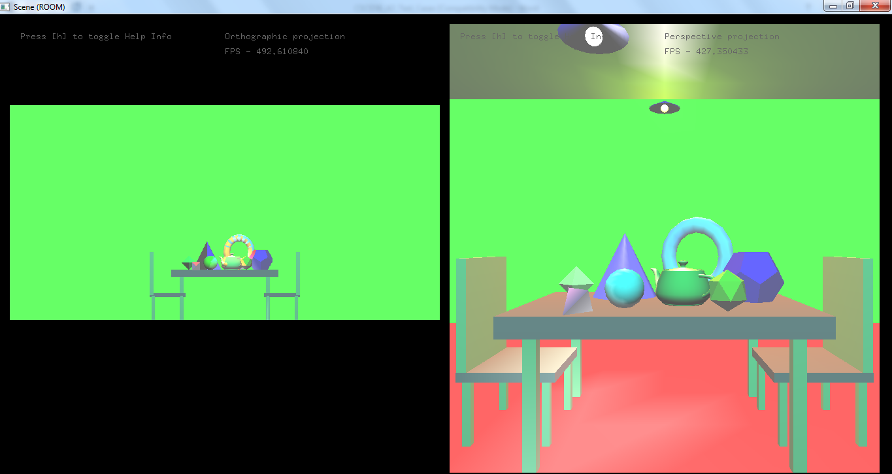

<Test Case #6a : Paste Screen Capture 2
=> Disco Light 1 “On” >

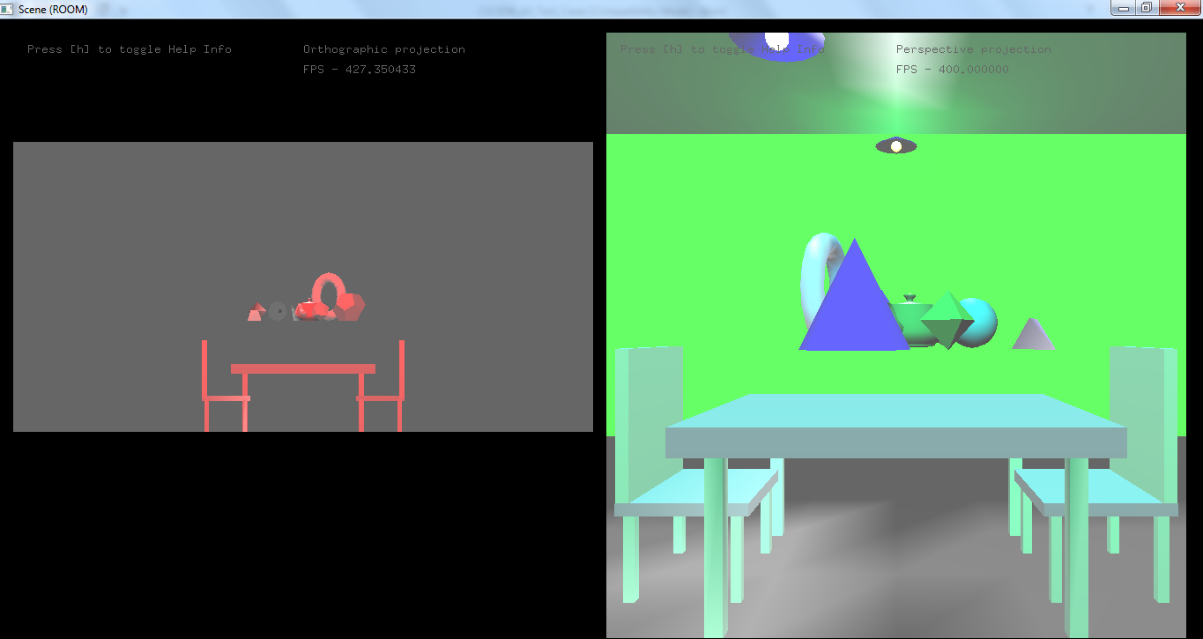

(Advance Task) Test Case #6b – Implementing Disco Light 2

- With the exception of Light Source 1 and Disco Light 2, switch OFF all other light sources

- Leaving Light Source 1 on, do the following screen captures:

- Screen Capture 1 – with Disco Light 2 off
- Screen Capture 2 – with Disco Light 2 on

- In CSCI336_A3_Criteria_Checklist.xls, for test case #6b, in column E, type in the keyboard key(s) to press, to toggle Disco Light 2 on / off

NOTE :
In CSCI336_A3_Criteria_Checklist.xls, please fill up the lighting properties values (Ambient, Diffuse, etc) for Disco Light 2 (in the corresponding row) from column E onwards.

<Test Case #6b : Paste Screen Capture 1
=> Disco Light 2 “Off” >

<Test Case #6b : Paste Screen Capture 2
=> Disco Light 2 “On” >

(Advance Task) Test Case #6c – Implementing Disco Light 3

- With the exception of Light Source 1 and Disco Light 3, switch OFF all other light sources

- Leaving Light Source 1 on, do the following screen captures:

- Screen Capture 1 – with Disco Light 3 off
- Screen Capture 2 – with Disco Light 3 on

- In CSCI336_A3_Criteria_Checklist.xls, for test case #6c, in column E, type in the keyboard key(s) to press, to toggle Disco Light 3 on / off

NOTE :
In CSCI336_A3_Criteria_Checklist.xls, please fill up the lighting properties values (Ambient, Diffuse, etc) for Disco Light 3 (in the corresponding row) from column E onwards.

<Test Case #6c : Paste Screen Capture 1
=> Disco Light 3 “Off” >

<Test Case #6c : Paste Screen Capture 2
=> Disco Light 3 “On” >

(Advance Task) Test Case #6d & #6e –
Disco Lights Movement / Flashing and Ornament dancing

- Raise your hand & call out to your tutor when you finished Test Cases 1 – 6c and updated the entries in CSCI336_A3_Criteria_Checklist.xls

- Demo your program to your tutor, to prove that your disco lights can move / flash, and your ornaments can dance!

- If your demo is successful, remind your tutor to note this in his namelist!

<Test Case #6d & #6e : No need to paste screen capture! Remember to update your Excel checklist … >

(Advance Task) Test Case #6f –
Orthographic and Perspective view Sub-Windows

- Start up your program

- Resize your program window to display the Orthographic and Perspective view sub-windows

- Do a screen capture

<Test Case #6f : Paste Screen Capture
(showing the 2 sub-windows) >

